**Step 1: Connect to Azure Cloud Shell**

1. Go to the [Azure Portal](https://portal.azure.com).

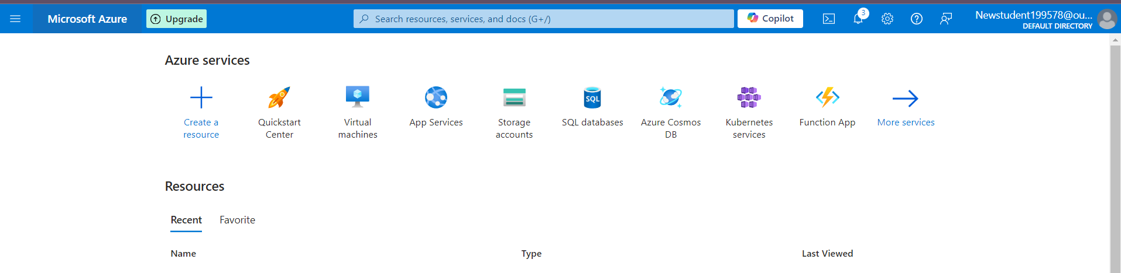

1. Click on the **Cloud Shell** icon (a terminal icon) at the top-right corner of the portal.

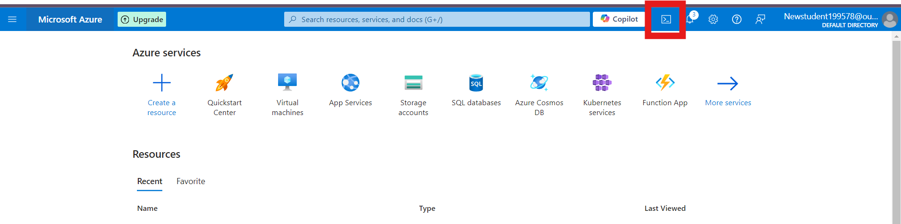

1. Select **PowerShell**.



1. The Cloud Shell will automatically connect to your Azure environment.

**Step 2: Create a Resource Group**

Once inside Cloud Shell:

**PowerShell:**

1. Run the following command to create the resource group:

**New-AzResourceGroup -Name "rg-1" -Location "South Central US"**

**1. Create 3 Storage Accounts with “Team” Tags**

# Create Storage Account for Team 1

**az storage account create --name shahidteam1 --resource-group rg-1 --location "South Central US" --sku Standard_LRS --tags team="team1"**

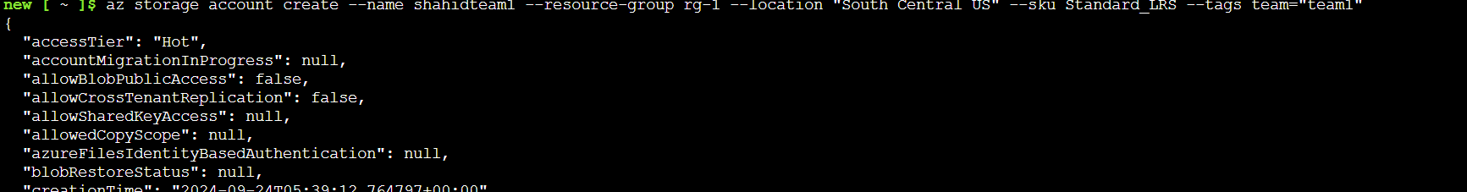

# Create Storage Account for Team 2

**az storage account create --name shahidteam2 --resource-group rg-1 --location "South Central US" --sku Standard_LRS --tags team="team2"**

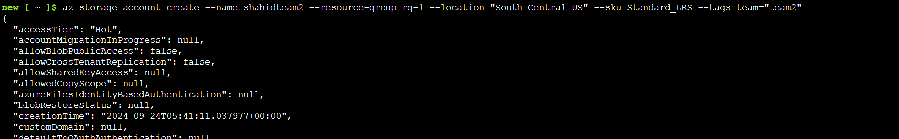

# Create Storage Account for Team 3

**az storage account create --name shahidteam3 --resource-group rg-1 --location "South Central US" --sku Standard_LRS --tags team="team3"**

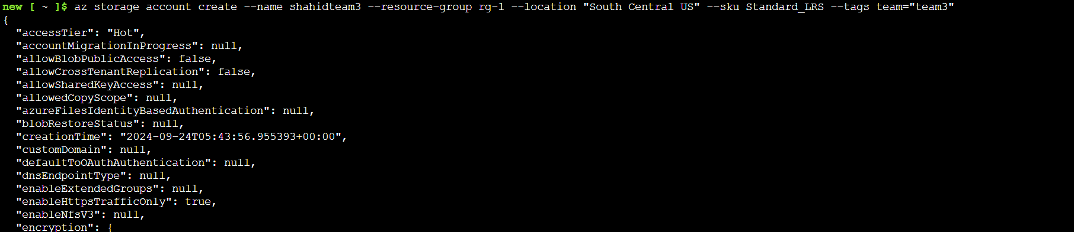

**2. Create One More Storage Account for Team 2**

**az storage account create --name shahidteam2additional --resource-group rg-1 --location "South Central US" --sku Standard_LRS --tags team="team2"**

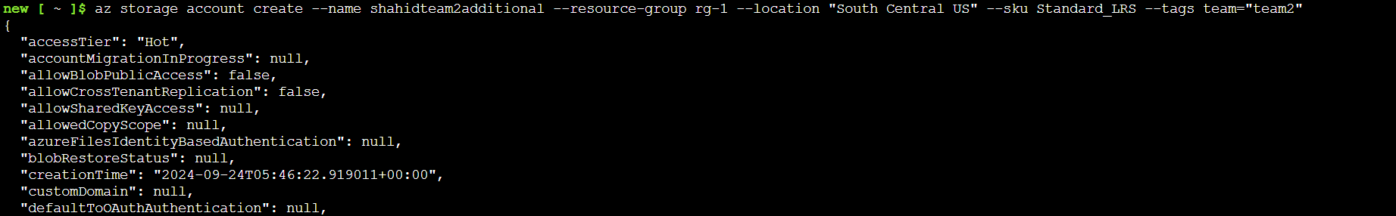

**3. List All Resources for Team 2 Using Tags**

**az resource list --tag team="team2" --output table**

